CONCLAVE 2026
06/04/2026
The ECE Association of PSG College of Technology organized CONCLAVE 2026 on 6th April 2026 at 3:00 PM in the F Block Assembly Hall. The event was a formal gathering aimed at fostering interaction between students, faculty, alumni, and industry professionals, while also serving as a platform to reflect on past achievements and present future plans.
The event was graced by the presence of Mr. Arun Karuppiah, Director of Pasumai Pharmacy, Coimbatore, and an esteemed alumnus from the ECE 2006 batch. His participation brought valuable industry perspective and served as a source of inspiration for the students.
The program commenced with Tamil Thai Vazhthu, setting a respectful and traditional tone. This was followed by the Welcome Address delivered by the Faculty Advisor of ECEA, who extended greetings to all dignitaries, faculty members, and students. The Presidential Address by the Head of the Department highlighted the importance of technical excellence, innovation, and active participation in both academic and extracurricular activities.
An Annual Report of the ECE Association was presented, showcasing the achievements, events, and milestones of the previous academic year. A flash video was then played, providing a visual summary of the activities and accomplishments of ECEA for the academic year 2025–2026. The introduction of the core committee for the current academic year followed, recognizing the efforts and responsibilities of the student leaders.
The Chief Guest delivered an insightful and motivating address, sharing experiences from his professional journey. He emphasized the importance of practical knowledge, industry readiness, and continuous learning, encouraging students to stay adaptable and committed to their goals.
The event also featured several key highlights, including presentations on final year projects that demonstrated innovation and technical skills, a session on placement preparation to guide students in career readiness, and the felicitation of GATE achievers in recognition of their academic excellence. The ECEA Yearbook for 2025–2026 was released, followed by the distribution of certificates and awards for various events conducted by the association. The office bearers for the academic year 2026–2027 were also officially announced.
Overall, CONCLAVE 2026 was a grand success, bringing together the academic community and creating an environment of motivation and celebration. The event not only recognized achievements but also inspired students to strive for excellence in their academic and professional journeys.

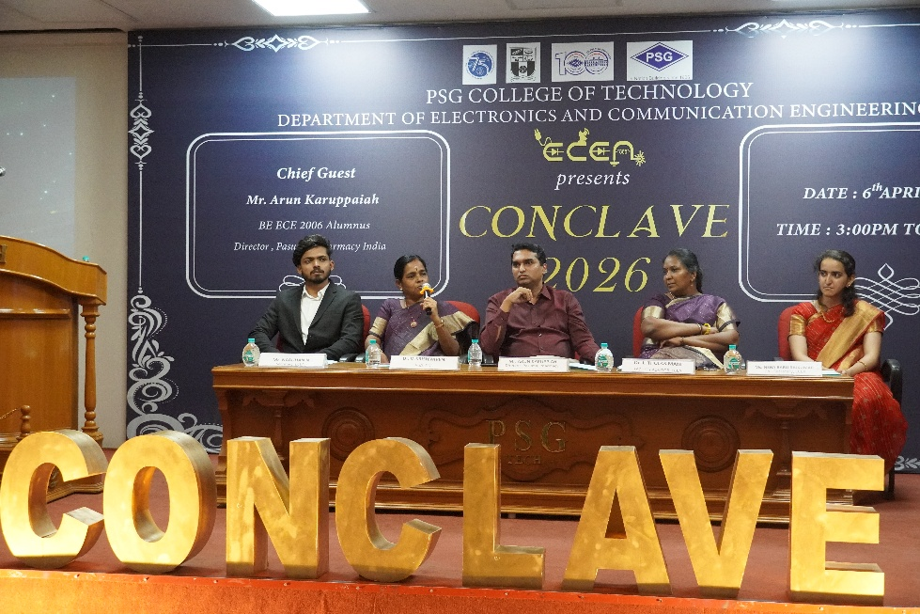
The Chief guest seated along with the Head of the Department, Faculty Advisor, Secretary and Co Secretary of ECEA
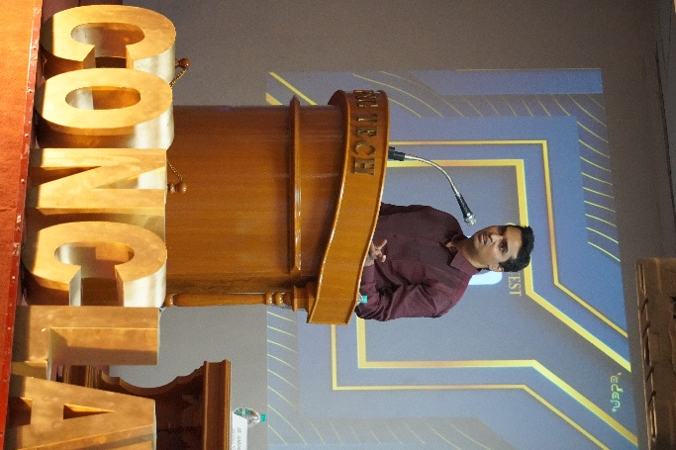
The Chief guest sharing his experience with the students

